**Write SQL query to solve the problem given below**

* **Consider a scenario in which you have to create a table called Nobel_win where you have given the information about the entity who has achieved nobel prize in a particular subject all over the world.**
* **Over here the table Nobel_win will contain attributes like year, subject, winner, country and category**
* **You need to use the sql commands to create the table given and to solve the problem given below.**

CREATE TABLE Nobel_win(

years int ,

subject varchar(60),

winner varchar(60),

country text ,

category text

);

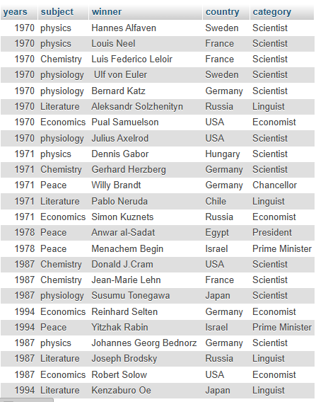

|  |
| --- |
| **Now make sure to solve the following query :**  ● **Write sql query to find the nobel prize winners of the year 1970. Return year,subject and winner**  **ANS :-**  SELECT years , subject , winner FROM nobel_win WHERE years=1970; |

|  |
| --- |
| ● **Write sql query to find the nobel prize winners in chemistry between the years 1965 and 1975. Begin and end values are includedReturn year, subject, winner and country.**  **ANS :-**  SELECT years , subject , winner , country FROM nobel_win WHERE subject='chemistry' AND years BETWEEN 1965 AND 1975; |
| ● **Write sql query to retrieve the details of the winners whose first name matches with the string ‘Louis’. Return year,subject,winner,country.**  **ANS :-**  SELECT years , subject , winner , country FROM nobel_win WHERE winner LIKE 'Louis%'; |
| ● **Write sql query to find Nobel prize winners for the subject that does not begin with the letter ‘P’. Order the result by year, descending and winner in ascending.**  **ANS :-**  SELECT * FROM nobel_win WHERE subject NOT LIKE 'p%' ORDER BY years;    SELECT * FROM nobel_win WHERE subject NOT LIKE 'p%' ORDER BY winner DESC;    SELECT * FROM nobel_win WHERE subject NOT LIKE 'p%' ORDER BY winner; |
| ● **Write sql query to find the details of 1970 Nobel prize winners. Order the result by subject, ascending except for ‘Chemistry’ and ‘Economics’ which will come at the end of the result set. Return year, subject, winner , country and category.**  **ANS :-**  [SELECT](http://localhost/phpmyadmin/url.php?url=https://dev.mysql.com/doc/refman/8.0/en/select.html) years,subject,winner,country,category FROM nobel_win WHERE years=1970 [AND](http://localhost/phpmyadmin/url.php?url=https://dev.mysql.com/doc/refman/8.0/en/logical-operators.html%23operator_and) [NOT](http://localhost/phpmyadmin/url.php?url=https://dev.mysql.com/doc/refman/8.0/en/logical-operators.html%23operator_not) category [IN](http://localhost/phpmyadmin/url.php?url=https://dev.mysql.com/doc/refman/8.0/en/comparison-operators.html%23function_in)('chemistry','economist') ORDER BY subject; |